% Computer Vision and Image Analysis Assignment 1

% 27 April 2019

% Jia-Qi Chen, u3181913

% Log: This file records the exploration of object detection algorithm for this assignment.

% Assumption: Goal is white, and ball is bright red(low hue, high saturation).

% If the goal and ball is of other color, need to adjust the source and threshold value to generate suitable binary images as inputs for functions.

% Manual: Execute imageProcessing.m and input a image file name including file extension to operate on image. Execute videoProcessing.m to operate on image.

1. **Likeobject detection**
2. SURF(Speeded-Up Robust Features)

SURF is a series built-in functions in Matlab Computer Vision System Toolbox.

1. Ball (grayscale)

Result: Not about to detect any SURF feature on the ball template.

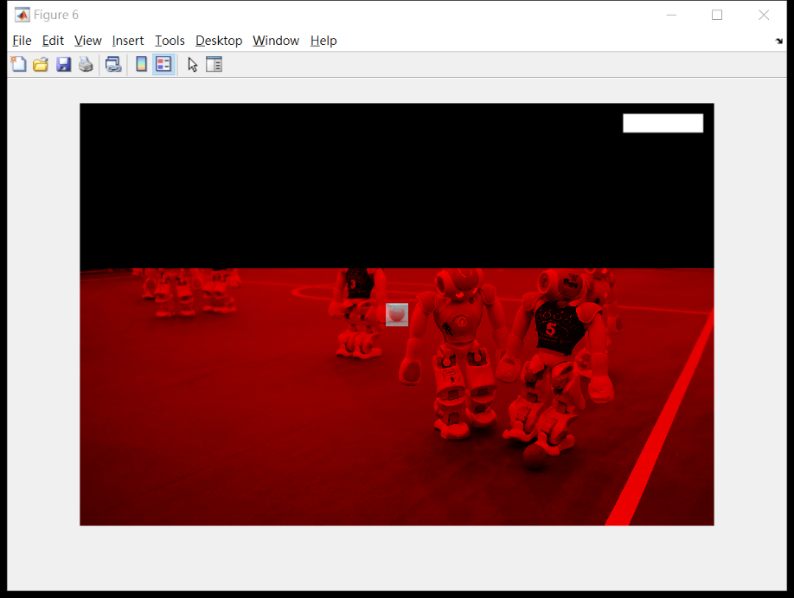

1. Goal (grayscale)

Results: regardless of the form of goal template, either the whole or parts, SURF was not able to have stable successful match in different images.

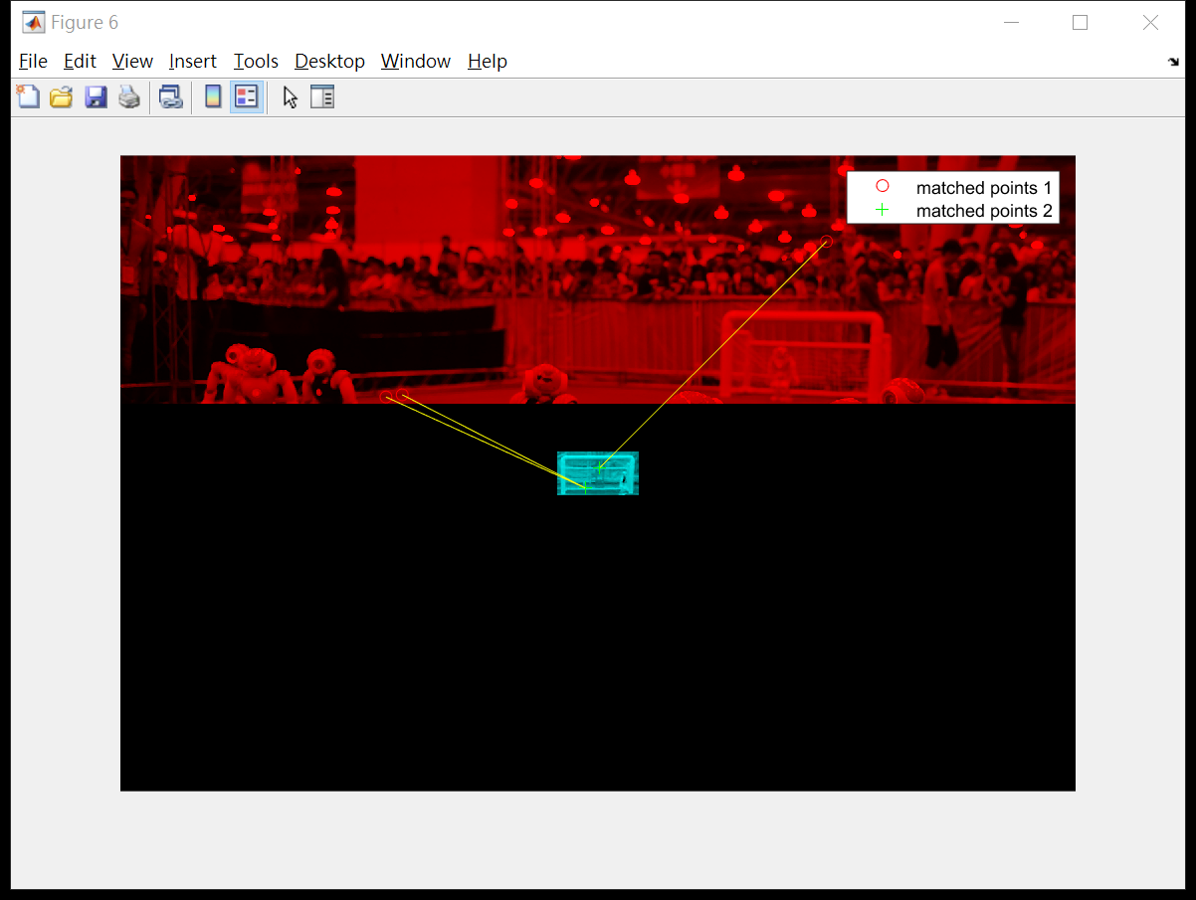

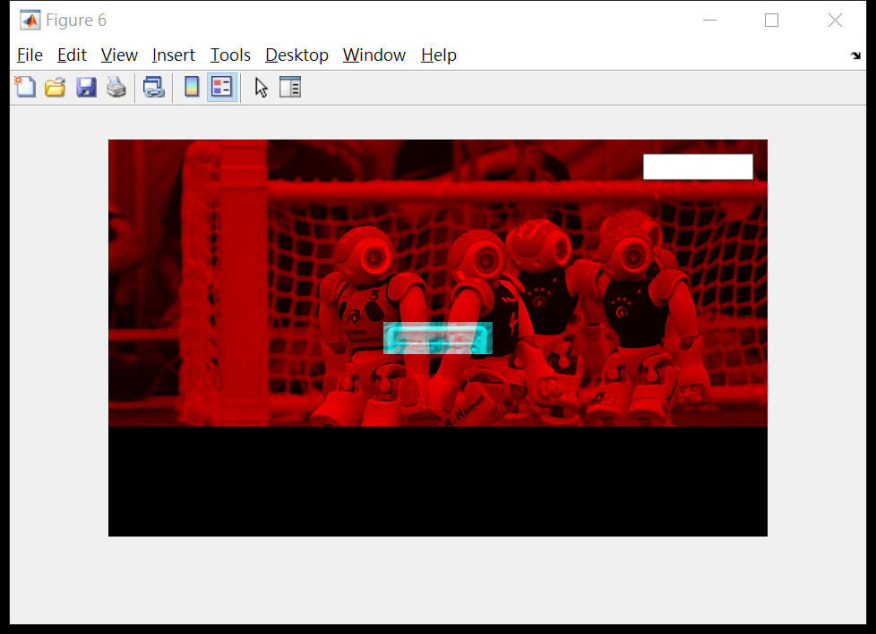

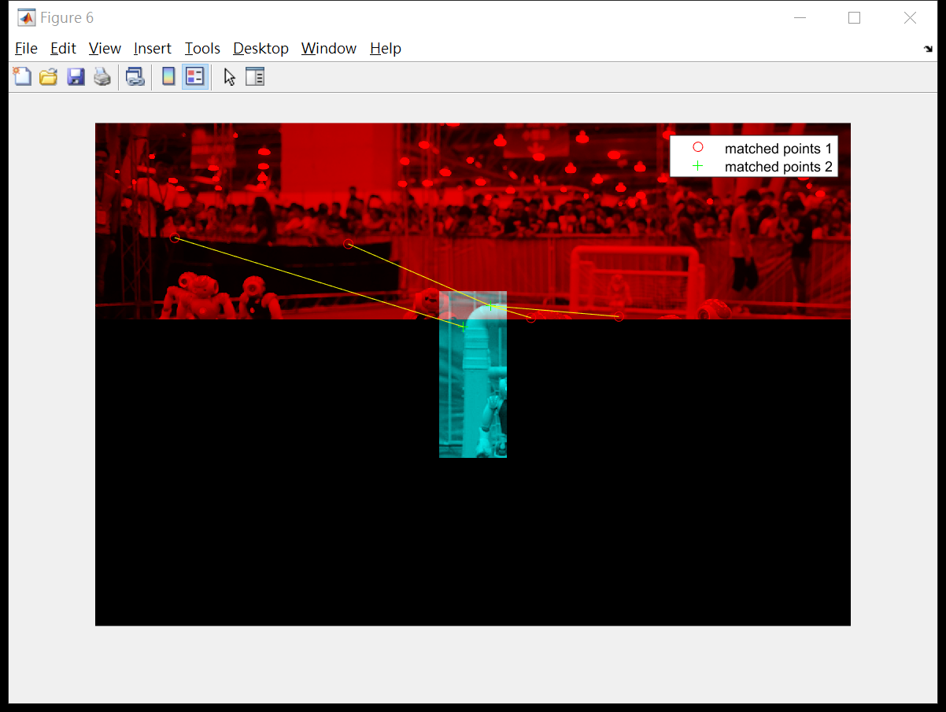

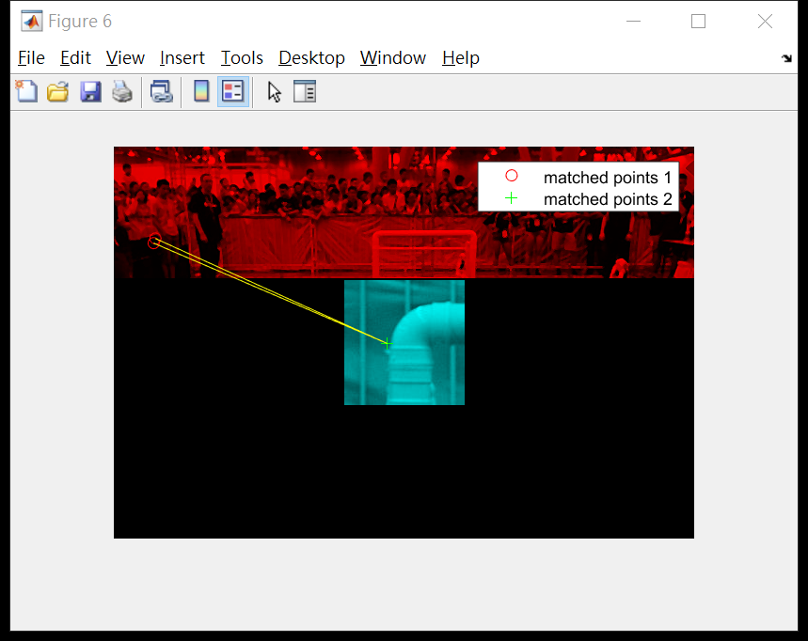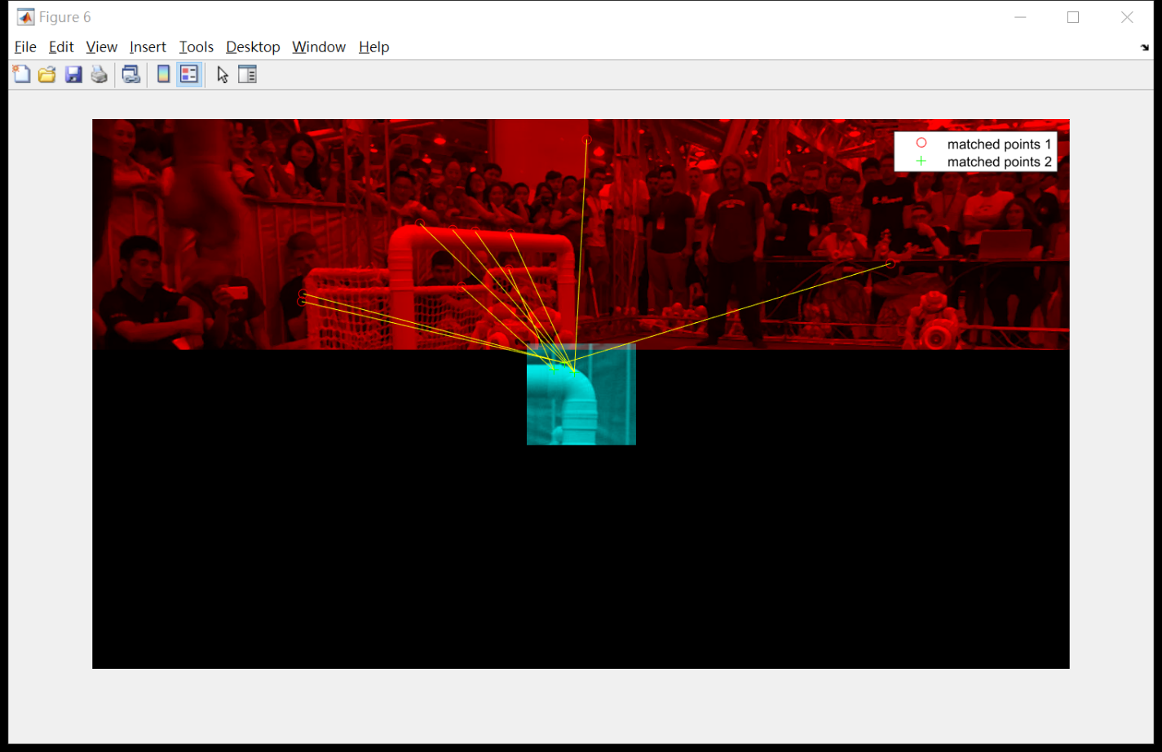

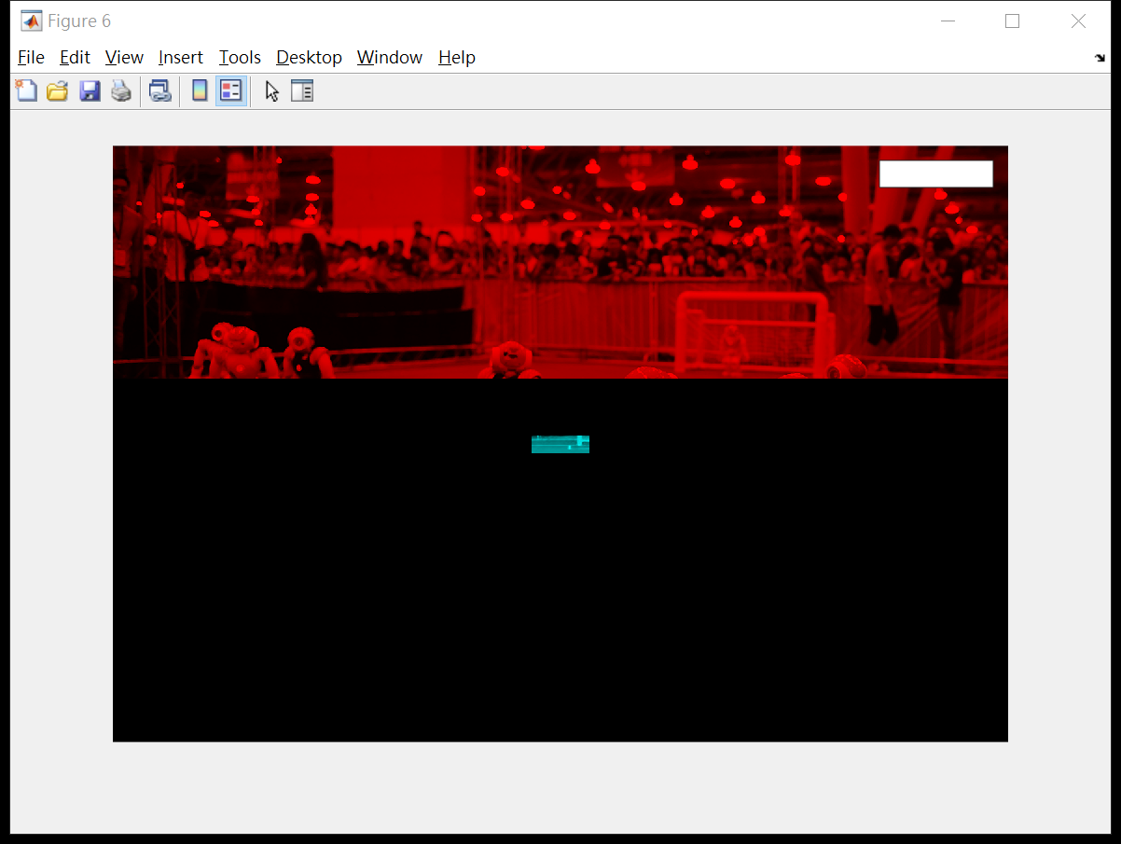

1. Goal frame(binary image)

Result: neither the whole frame nor the corner was able to stably match across different images.

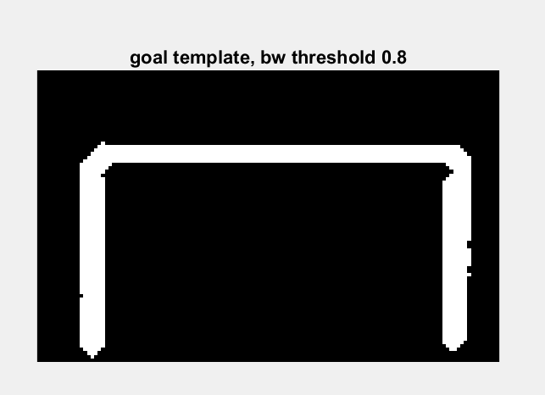

Goal frame template cropped from ‘Robocup_Level1_image2.jpg’.

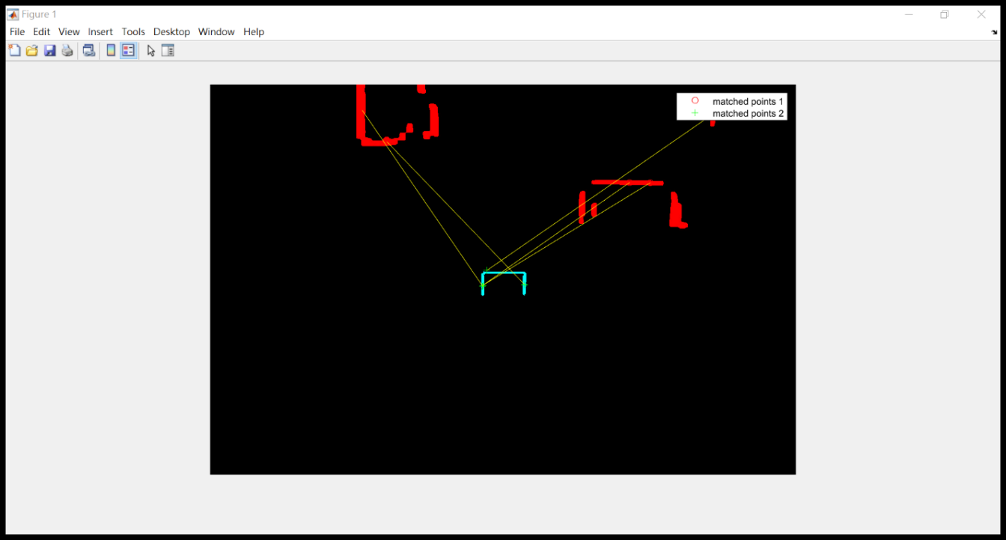

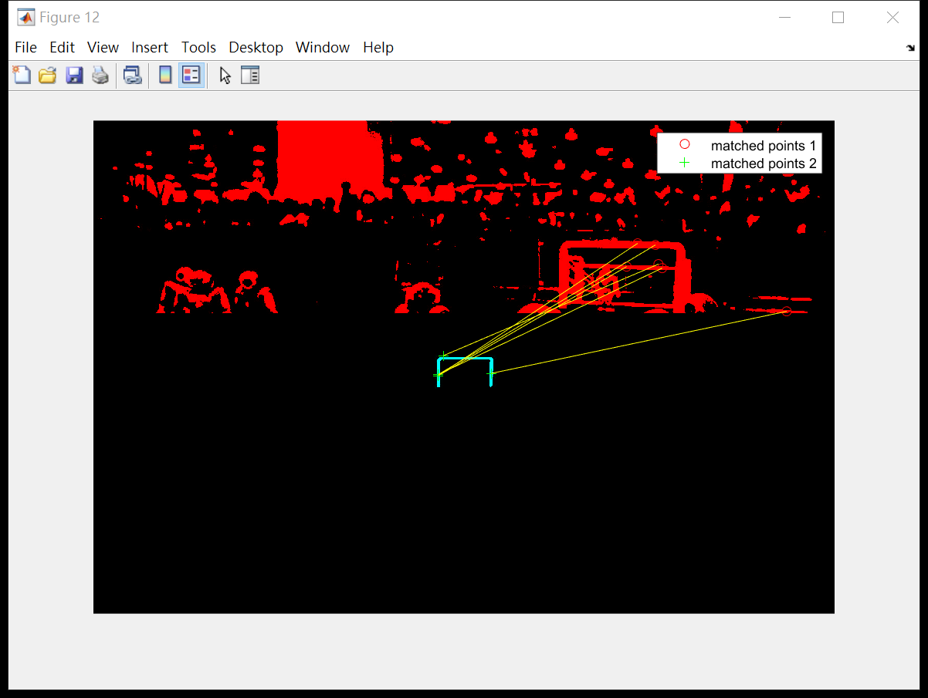

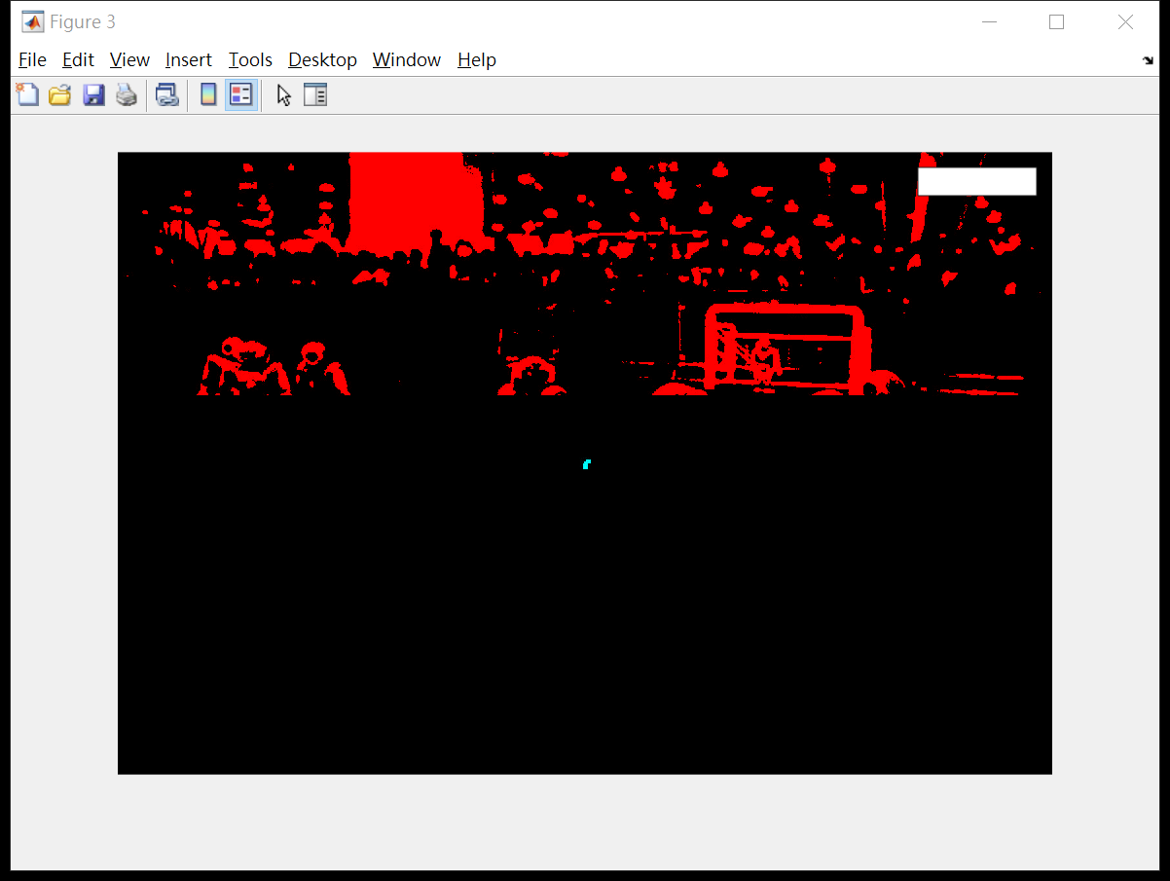

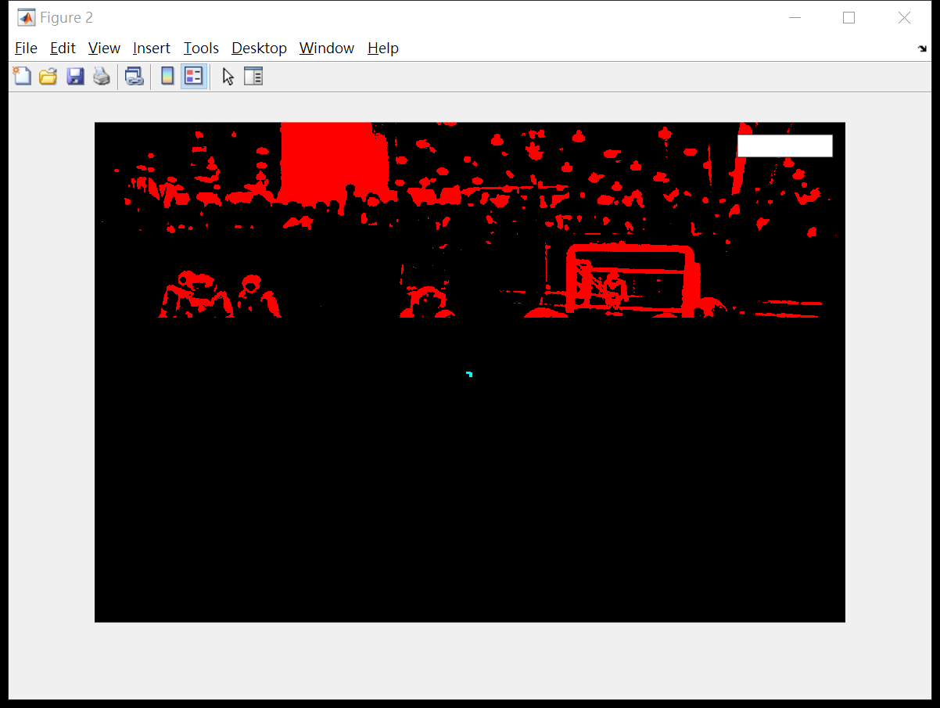

SURF fails to match the goal frame template with the goal from ‘Robocup_Level1_image1.jpg’

1. NCC

Preprocess the template and target image into binary images.

Result: Not scale invariant, and the black pixels affects NCC values.

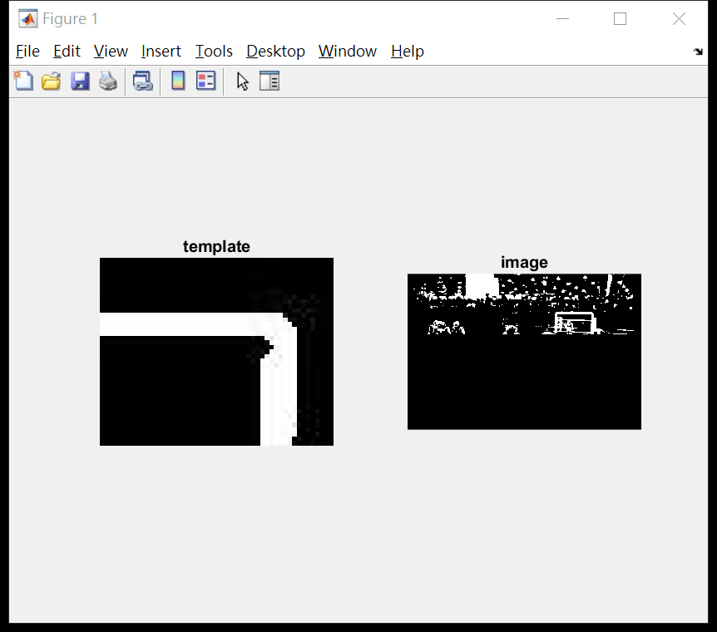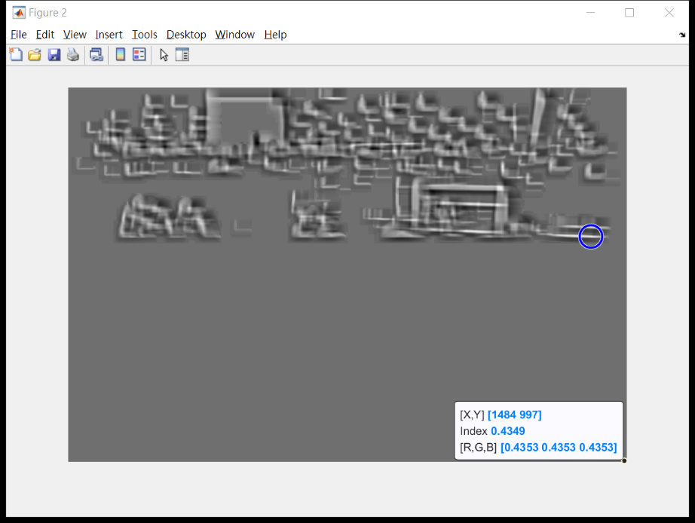

Preprocess the template and target image into grayscale images.

Result: Not scale invariant, therefore generated false positive.

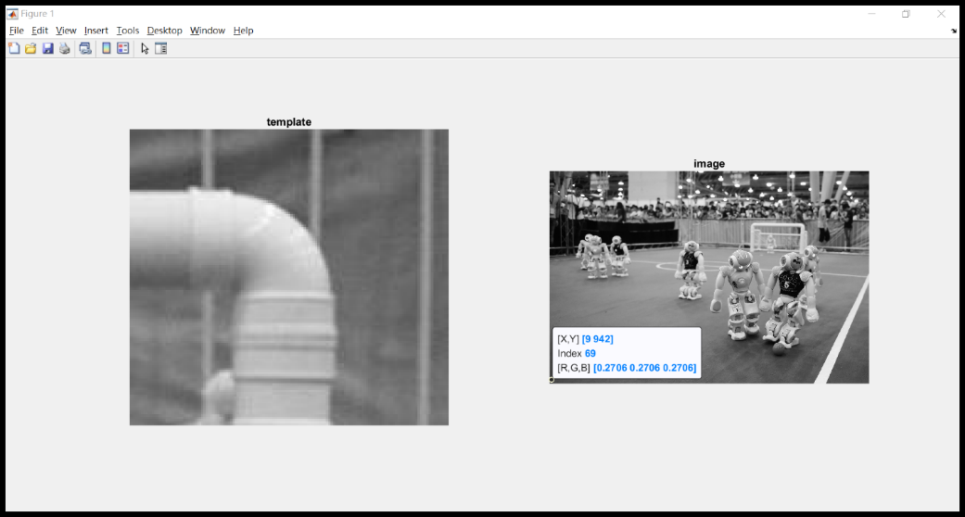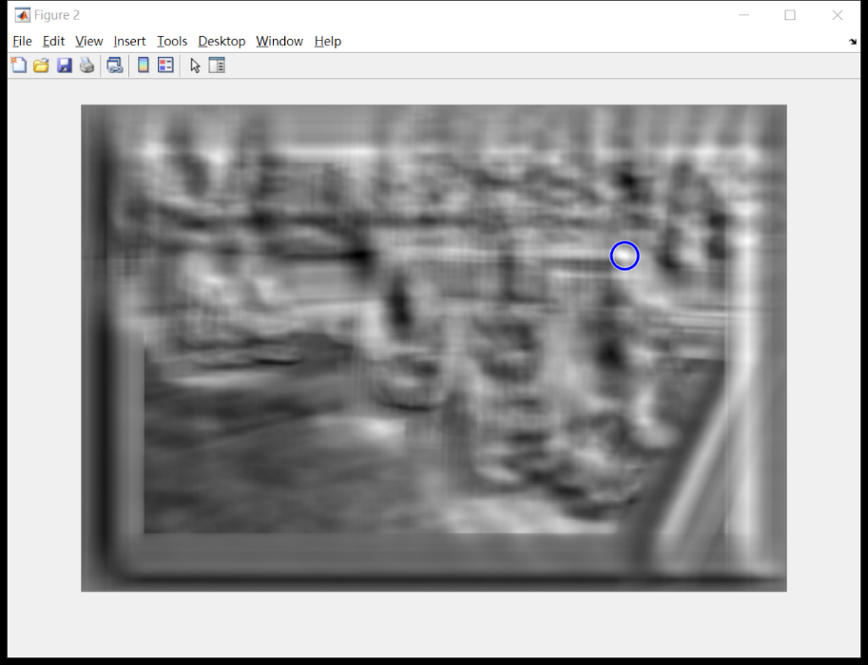

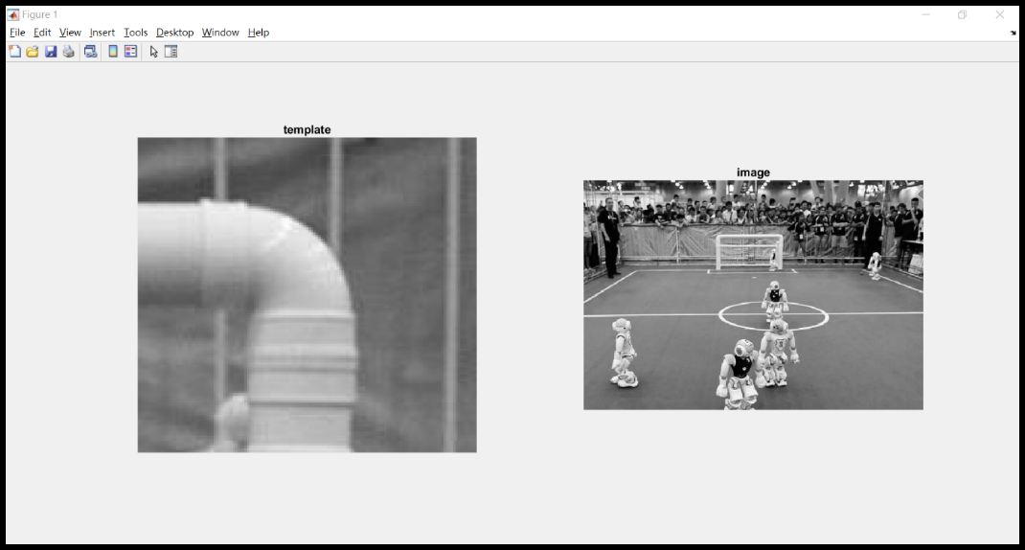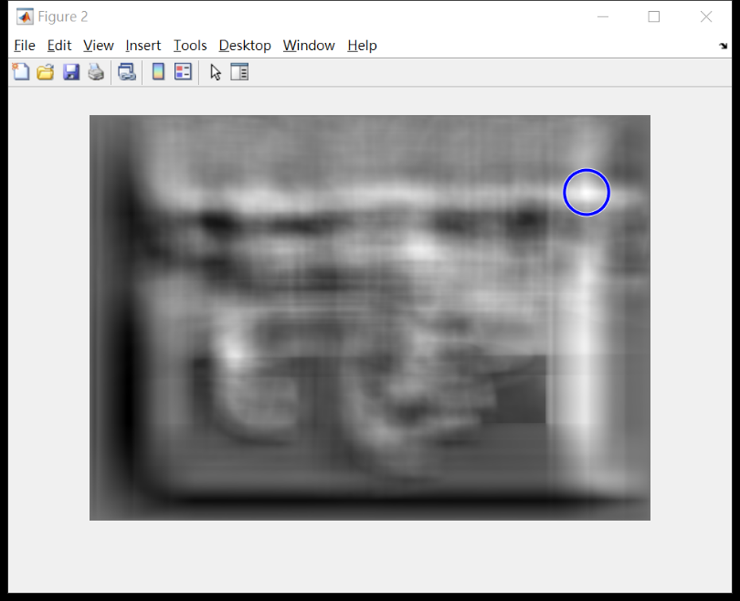

1. **Guassian smooth application**

Idea: By observing the binary images turned from hsv saturation channel, one can see that the goal poles and bars are almost vertical and parallel. With this feature, applying Guassian smooth on x or y axis followed by thresholding can exclude smaller spots in the background.

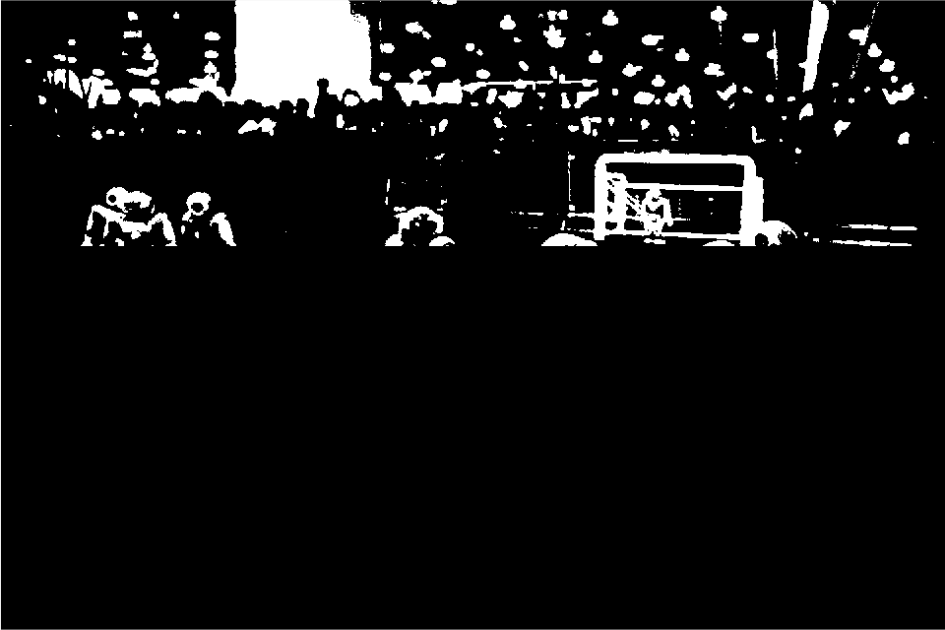 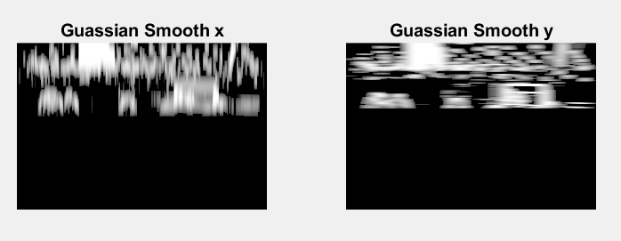

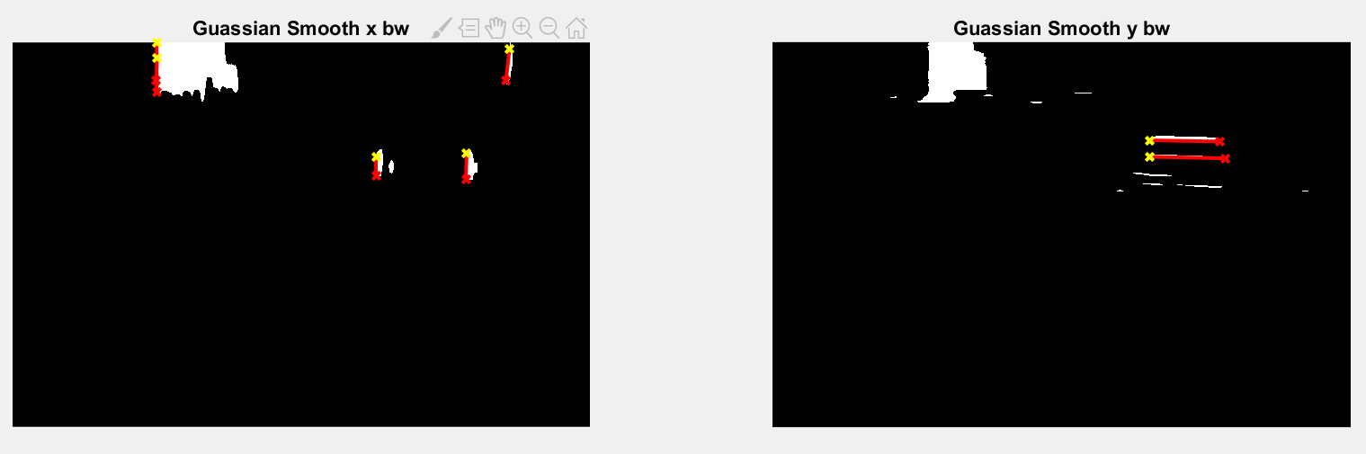

The overlay of the Hugh lines found based on vertical and horizontal Guassian Smooth can be used to locate the goal frame.

The top horizontal component of the goal is less likely to be obscured by robots, so certain rules can be set to determine the top bound of the goal.

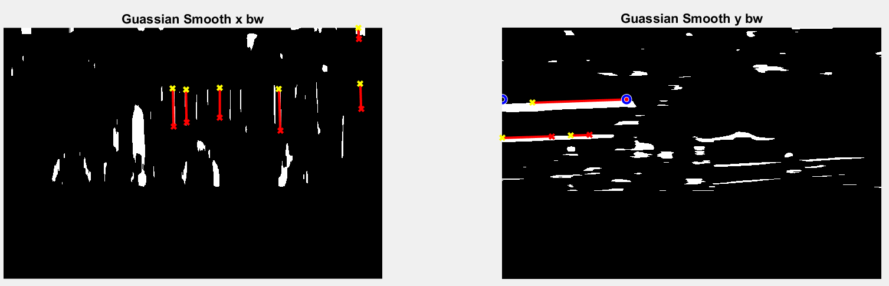

(Different image)

With the top bound determined, then use vertical Guassian Smooth image to probe the left bound and right bound.

